Computer Language Fundamental Principles

Automatic Containment
The concept of automatic containment is about translating a referential structure to a containment structure.

To be able to work out the idea, some concepts need to be ignored and reconsidered later (concepts such as globality).

A slice of referential structure
The containment structure depends on the display of a diagram. One thing that will make it doable, to convert a referential structure to a containment structure, is that you will never display the complete referental structure: you will always display a slice of the referential structure. The contents of one object are shown and it goes but x levels deep. That way you always display a slice of the referential structure: cut off from the top at the parent object and cut off at the bottom x levels deep.

The main solution
The main solution to converting a referential structure to a containment structure is demonstrated with an example. The following reference structure is considered:

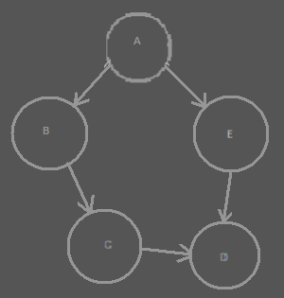

The circles are all objects. Object A for instance has two references: one to object B and one to object E. Two objects refer to object D: both object C and object E refer to object D.

In a Computer Language diagram, the references would look something like this:

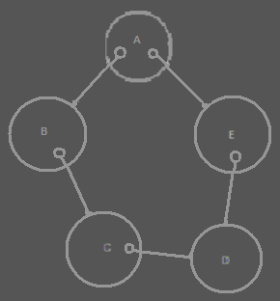

The references are considered things that are contained inside an object.

The references are directly converted to a containment structure, by simply displaying one thing inside another instead of one thing referring to another:

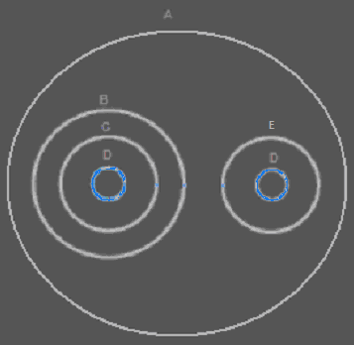

The diagram above actually displays the same structure as the other diagrams. Instead of giving object A a reference to object B and E, object B and E are placed directly inside the object A. But there is a problem. There are two objects, that have a reference to the same object. In the containment structure this means, that two object contain the same object. The same object is displayed twice in the same diagram. In the diagram you can see, that object D is displayed twice: once contained inside object C and once contained inside object E.

To solve this ambiguity, you connect the two symbol that represent the same object with a line:

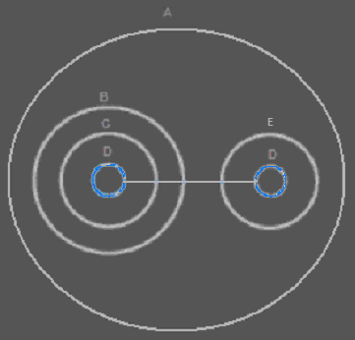

Now both symbols represent the same object.

Regardless of which diagram you find prettier, the containment diagram displays more clearly what is part of what. But now you have the problem, that a single object is not represented by a single symbol anymore.

One symbol will be selected to represent the object itself, while the other symbols are considered mere references to the object. How this single symbol selected is explained next.

The closest mutual parent
Multiple symbols in a diagram can represent the same object. In that aspect, a containment diagram does not explicitly express a place where the object really is. It does not display where the object is contained, just where object references are contained. Only one of the symbols should be considered the object itself, and the other symbols mere references.

To point out the actual object, you have to ask yourself: what would the real containment level of the object be? You will have to go upward in the containment hierarchy, until you find the level at which all the references are contained inside a single symbol. That is the actual containment level of the object:

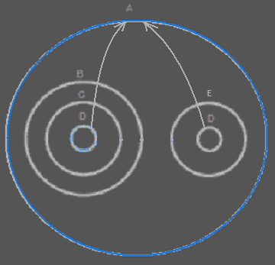

The blue circle is the closest containment level in which both object references are contained. It is the larger whole which the object is part of.

The container of the object is also called the closest mutual parent of the object references.

The mutual parent connects all the references together. The mutual parent should be where the object itself is specified.

The diagram above does not even display the symbol, that represents the object itself. We have yet to put a new circle in the diagram directly inside the closest mutual parent of the references:

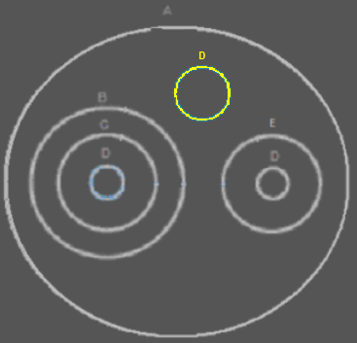

It is an imaginary reference, directly placed inside the closest mutual parent. It is called imaginary, because its direct container doesn’t really directly refer to the object.

The other references will be connected to the symbol that represents the object itself:

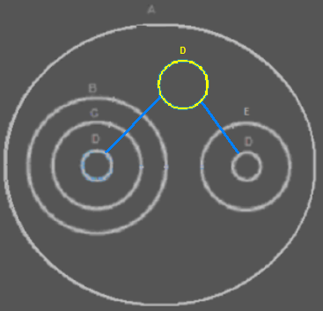

This solves the problem, that the same thing is contained in multiple places. This only happens when the same object is referenced in multiple places.

To find the symbol, that represents the actual object, you have to follow the reference lines upward in the hierarchy.

This is the way the location of an object is expressed in a diagram. Now I will explain the different phenomena that can occur when you apply this method.

Branched out reference lines
Here is a more complex example, in which the reference lines branch out into a tree structure and multiple imaginary references are created. This happens when an object is present in several different branches of the containment structure:

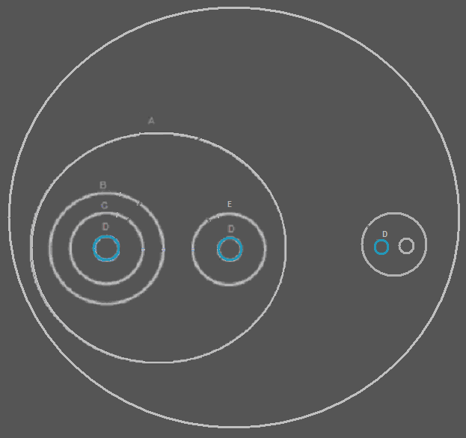

Imaginary references will be created at every mutual parent in the structure, that contains multiple references:

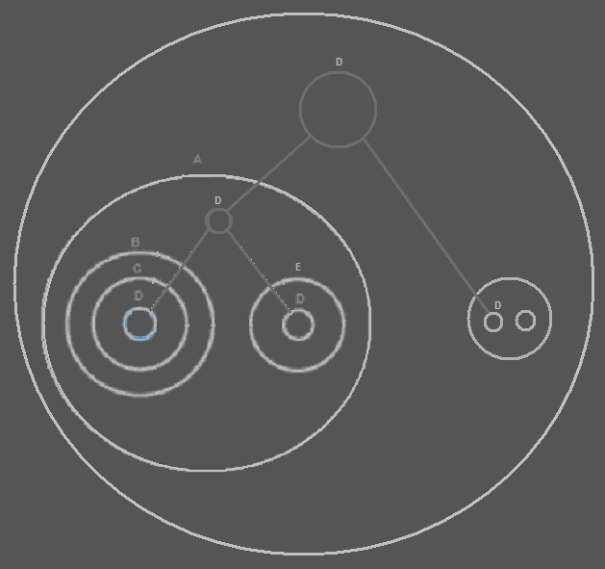

You might say, that the symbols representing object D could also have all referred to a single symbol: the one highest in the structure, without an extra imaginary reference in between. But by creating an extra imaginary reference, nodes are displayed at all points at which there is a larger whole, that contains multiple references to the same object.

The reference to D on the highest level is considered the object itself:

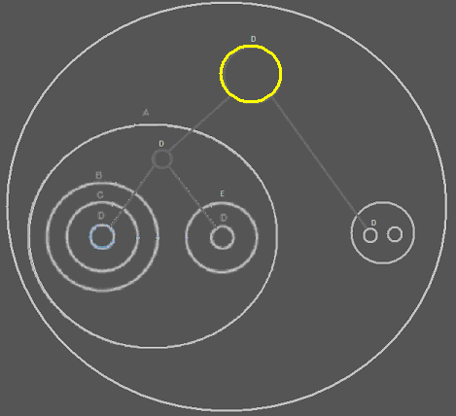

The other symbols of D are mere references to the object.

The containment structure splits up the object structure into branches, and the reference lines branch things back to the same object.

From the target symbol’s point of view, you can easily see in what different places the object is used, because it just directs to them in a tree structure.

Reference already there
When a diagram contains multiple references to the same object, the target object is almost always is an imaginary reference. Sometimes however, a real object reference may already be there. In that case the target object is a real reference, instead of an imaginary one.

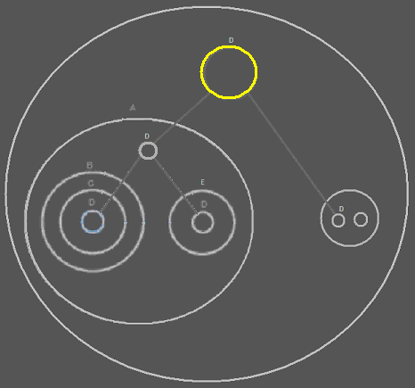

References in between
Back to an easier example, in which I explain another phenomenon.

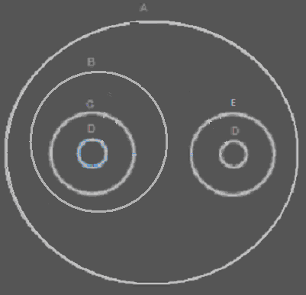

Another real reference to D could be closer upward in the hierarchy than before:

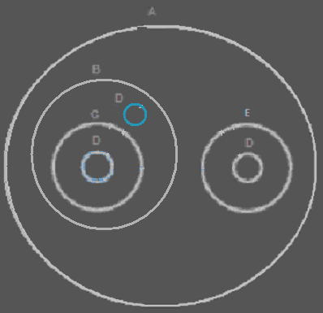

In that case the real reference is put in between the connections to the target object:

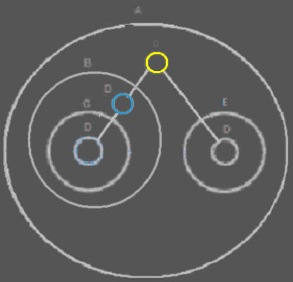

This already conforms to the procedure of using the mutual parent: object B indirectly contains multiple references to object D, so it is a mutual parent.

Reference to parent
In the examples before, the same object never occurred in within the same branch of containment. The following situation is also possible:

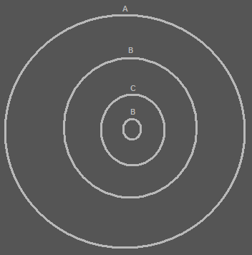

In the diagram above object B contains object C, and object C contains object B again. In that case the mutual parent of the two references to B is A and there is no choice, but to make the reference to B directly contained in A the target object and draw the diagram as follows:

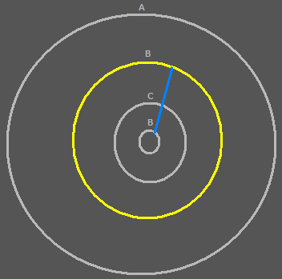

The reference to B on the higher level becomes the target object, because object A is a mutual parent of both references to object B, and there is already a reference to B present inside object A.

References at the same level
In the following situation you can’t identify a single target object:
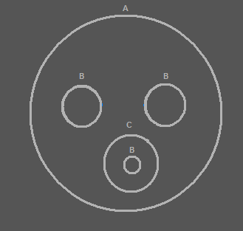

Object A is a mutual parent because it directly or indirectly contains multiple references to the same object (B). However, the mutual parent directly contains multiple references to the same object. In that case all the references inside the mutual parent would represent the single object. To not obscure things, an arbitrary one is selected as the target object.

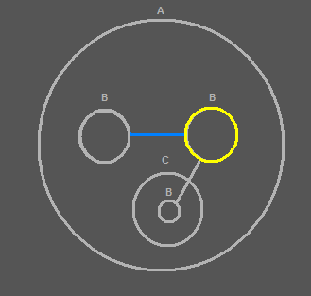

Summary
When you display a diagram in a purely referential style, a single symbol represents a single object. There are no multiple symbols, representing the same object.

When you display a reference structure as containment, and there are things, that refer to the same object, then all of a sudden the same object is displayed multiple times and in totally different places.

The diagram does not explicitly display individual objects anymore.

The referential structure is treated directly as an automatic containment structure, but we still need to determine how to display, what symbols in the diagram represent the same object.

This is solved by connecting the symbols that represent the same object with lines.

But to have a single symbol, that represents the object itself, symbols of the same object all need to point back to a single symbol. That single symbol represents the object itself. The other symbols are mere references to the object.

But where is this object placed? You’d have to go upward in the containment hierarchy, until you find the level at which all the references are contained inside a single symbol. That is the actual containment level of the object.

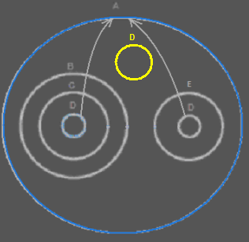

The symbol representing the actual object is placed in the highest mutual parent of all the references.

The references are connected by tying a deeper reference to a higher reference.

The containment structure splits up the object structure into branches, and the reference lines branch things back to the same object.

In each symbol, that indirectly contains multiple references to the same object, an new node is created.

That way, a complex referentual structure is displayed as a more tangible containment structure, even though it is not pure containment. In that display, multiple symbols represent the same object, but this is elegantly solved, by choosing a clear spot at which to put a single symbol, that represents the object itself, while other symbols are considered mere references to the object. The single symbol is also placed in a spot that is the bigger whole in which multiple object references are contained.

Zooming in, zooming out and making changes
You can move through the diagram by zooming in on an element of the diagram, and only display the contents of that element. You can also zoom out, and display the contents of the container of the object currently displayed. Since a single object can have multiple containers, the program should remember the path you before you got to the object.

Whenever you change something in the object structure, the containment structure is still easy to draw out, because it is the same as the referential structure. But the reference lines and imaginary references, that make the object references lead back to a single symbol, just need to be wiped out and recalculated. Which of the symbols is a mutual parent can totally change. The reference lines and imaginary references are also recalculated as soon as you move upward in the hierarchy, displaying the contents of the parent of the object you were displaying. The same goes for moving downward in the hierarchy: when you only display the contents of one of the children of the object whose contents you were displaying. In all those cases, the reference lines and imaginary references need to be recalculated. Fortunately it is always a limited set of symbols for which you are recalculating this: you are only displaying the contents of a single object, and you display symbols but x levels deep.

Analogy to the real world
The way diagrams are displayed, has an analogy to the real world.

Let’s say your TV contains an electronic part. But what if you have a stereo set that also contains this electronic part. When you only focus on the TV, it is the only object that contains this electronic part that you need to be concerned with. When you look at the whole room, you see that this type of electronic part is part of two appliances in the room. Imaginarily, the whole room is the container of this kind of electronic part. The whole room is the indirect mutual parent of both electronic parts of this type, because the room contains two appliances, that directly contain this electronic part. This gives the room an imaginary reference to this type of electronic part. The room doesn’t really contain the electronic part. The appliances could be carried out of the room, and then the room looses its imaginary reference to the electronic part, but the appliances still contain it.

What if you have more appliances in your house, in multiple rooms, that also contain that electronic part. In that case, looking at it from the perspective of your whole house, the whole house has an imaginary reference to that part. This type of electronic part belongs to your whole house in that case. That way you could also look at the whole neighborhood. Perhaps multiple houses contain appliances with the same electronic part in it. In that case this type of electronic part is part of the whole neighborhood. But if you’re just looking at the room you are in, you are not considering the whole neighborhood. You are only bothered with your room. If you focus on just your TV, you just don’t pay attention to the fact that your TV is part of a whole house: the electronic part is just part of your TV.

The containment level of this type of electronic part, just depends on the perspective from which you look at it.

And this is what also happens in the diagrams.
That way, something can get a different containment level depending on the perspective from which you look at it. Something does get a unique containment level, from within that perspective.

Ignored concepts
To easily understand the idea of automatic containment, a few concepts were ignored. In this section I will consider the concepts that earlier were ingored.

Here is a sum-up of all the concepts that will be considered here.

- Classes, interfaces and methods

At first, only object references were considered. Classes, interfaces and methods were ignored..

- Duality of relations

For now you are going to have to ignore that relations are bi-directional, and just go for mono-directional references to objects.

- Central registration lists

You also should ignore the fact that a module may contain a central list of all objects of a certain class.

- Globality

- Lines as pointers

It was ignored, that lines in a diagram might be considered pointers.
Earlier on lines simply indicated which symbols represented the same object.

Classes, interfaces and methods
At first, only object references were considered. Classes, interfaces and methods were ignored. To cut to the chase: it simply works the same for the display of classes, interfaces and methods.

In Computer Language the class of an object is actually also an object. In Computer Language, another object simply serves as the prototype for the object, with default values already specified in it.

When you first display containment, without lines leading back to a single object and everything, you don’t see mutuality of classes. Just like you don’t see mutuality of objects. To express the mutuality of classes, lines and imaginary references are positioned the same way, as they are for lines leading back to the mutual object, but now it is lines leading back to the mutual class. Except: those lines are dashed instead of solid.

In Computer Language also an interface is simply an object. An object serves as the prototype for an interface of the object. When you first display containment, without lines leading back to a single object and everything, you don’t see mutuality of interfaces. To express the mutuality of interfaces, lines and imaginary references are positioned the same way, as they are for lines leading back to the mutual object, but now it is lines leading back to the mutual interface (= object serving as a prototype for the interface). Except: those lines are dotted, instead of solid.

For methods it works a bit different. Methods are not object. Methods are not displayed as circles. Their default display is a square. So they have totally different symbols compared to objects. But the way lines lead back to a mutual method, simply works the same as for objects.
There is more to the display of methods, but that’s not covered here. The main point is: the technique for displaying mutuality of class, interface, and method works the same as mutuality of objects.

Duality of relations
In the diagrams explained before, only mono-directional relations were considered. An object that referred to another object, didn’t make the other object refer back to the first object.

In relational programming it is common, that if one thing has a reference to another, the other thing has a reference back to it. But if you display that in the diagram, you just see too much recursion, and it is confusing.

Because it is unacceptable not to see this duality in a diagram, the following rules are followed.

Consider first of all, that if something contains another thing, the reference of parent to child is apparent, but the reference from the child back to the parent is also apparent already: just look a container of the child. So the duality of that relation was already displayed in the diagram.

The rule to follow is: if one direction of the relation is already displayed as going downward in the containment structure, don’t display the other direction of the relation as going downward again, because then you will be displaying the same relation twice.

So when something is already displayed as something’s parent, you don’t display the reference back to the parent as a child anymore. The display of a containment is already considered the display of a bi-directional relation.

Just accept that the display of a parent, is already the display of the reference back.

A funny effect of that, is that when you zoom in on an object, an object formerly a parent, all of a sudden is displayed as a child. Something else funny, is that if you zoom in on the parent, now displayed as a child object, you will be seeing the same thing as when you were two zoom levels up!

When one direction of a relation is displayed, the other direction is not displayed anymore. That is the rule.

One flaw in this is, that you might not easily see the relation type. An n → n relation is displayed as a 1 → n relation. A n → 1 relation is displayed as a 1 → 1 relation.
A solution may need to be found for that.

< ... >

Central registration lists
One problem I didn’t want to consider at first, was that a module might contain a registration list of all objects of a certain class. Because that would have given an object an exact location: that would have given an object a fixed place already, and all lines would have pointed to the central list, which would not make the diagram overviewable.

However, in the method found, I don’t think central registration lists are a problem anymore.
If a central registration list is visible in the diagram, it might become a target object and if it is not, it might not be.
The display of the diagram is simply dependant on the level of detail now and lines are not always pointing into a fixed direction. So I really don’t think this is a problem anymore.

Globality
Another thing ignored when working out the idea is globality. Globality also gave an object a fixed position. All lines to that object would have been pointing to the global object, which would make things not overviewable.

Global objects, that are accessed by objects currently displayed in the diagram, are simply displayed as imaginary references. They are not really there, but they are accessible from anywhere within the globality and referring to it creates an imaginary reference to it. If you are referring to an imaginary reference and there is no real reference in the picture, that should be a signal, that you are referring to a global object.

<
That’s not right. When a class is specified on site A, and an object of that class resides inside a globality on site A, the class on site A does not have access to anything accessible on site A from within that globality.

I guess a site does not join in on automatic containment in the sense, that the residence of an object is dependent on the perspective from which you view the object. A site really is in a fixed spot.

This also counts for globality.

There is access control going on.

This problem goes deeper, than just globality or even sites.

In automatic containment an object does not have a fixed spot. It can be referenced from anywhere, but where it’s really stored is not specified.
The target object is different depending on from what perspective you look at it.

If an object doesn’t really have a fixed spot, then where is its storage location?

Where the storage location is should be fixed somehow. You might not really care from a logical point of view, but it should be stored somewhere.

The storage location gives the object its ID.

Perhaps some of the diagram’s symbols just not only represent a logical object, but also represent a physical object, such as a site, or a storage device or a central list, or something.

If an object is stored on one site, it may logically be resident in multiple locations, but its physical position is still on that site. And this physical storage also has a symbolic representation on that site.

Perhaps if you’re not pointing to a symbol that represents a physical storage location of the object, you should never end the reference lines at an object on the highest level in the view. Perhaps you should always let it point out of the diagram to somewhere you can’t see in the diagram, thus suggesting that this is not the target object. The target object is the actual physical location of it. You might even display cache layers (of some sort) as symbols, that evenually lead back to the target storage.
If you let a last reference line point out of the diagram, you don’t have to specify where it leads, just that it still leads somewhere. If you go one containment level up, you might find another intermediate reference there.
That way the target object actually does not change according to the way you look at: just the highest level in view is apparent.
The target object is still a physical location of something.

The physical locations are actually the real target objects.

You could even display the name of the physical location in the reference line going outwards

This does make central registrations lists ok, and residence on a specific site ok, etcetera. Fixed residence of classes, interfaces and methods too.

For globality, more things still need to be considered.

Gee, this changes things a little bit. For the most part, just another reference line pointing outward.

>

Lines as pointers
In an earlier version of the diagrammatic way to express a system, a line was not only simply to express mutuality of things. A line was also a pointer. So when you let a line point to a symbol, and that symbol also has a line pointing to the next thing, you actually have made a pointer to a pointer.
In the diagrams explained above, you don’t have that. Something is always a pointer to an object, but never to another pointer. I simply don’t have multiple indirection here.

<>
You should be able to take over the class of another object, and as the class of the other object changes, the class of the pointer to the object also changes with it. That would be handy. That way one object can take over the class of another. But... I can do that... another object can be used as a class. You simply point to that object for a class. If that object also redirects its class, the class of the first object automatically changes with the class of another object. But you just don’t see that in the diagram. So you can have multiple redirection of a class, but you don’t see it in the diagram!
However, multiple redirection of an object is not possible. This is because the object is the object itself, and a class is merely an attribute of an object, that can be redirected.
<>

> Er zullen wel lijnen bij gecreeerd worden.
Later moet je kijken hoe dit zich gaat verhouden
met echte pointers naar pointers.

<
Maybe fixed residence changes the view on not being able to have pointers.
Some things do have a fixed residence. In that way they are access controlled. The target object is always accessed through this other symbol.
When you create imaginary references, the reference lines are indeed not pointers, but only indicate which things represent the same object, but if something has a fixed residence and you connect a line to it, that is a pointer to something, every non-imaginary reference below that is really a pointer to the fixed residence.
If you create an intermediate fixed residence, that also points to another fixed residence, you have created a pointer to a pointer.

Is that so? I’m not sure. I’m tired. I’m just gushing out ideas.

>

<

The most important idea might be, that a target object might be more than bound to how you view something and imaginary: the physical location is the target object. So when a target object in the diagram isn’t the physical location, it points out of the diagram, and you may make mention of the name of the location in the out pointing reference line.
So perhaps that imaginary object residence is not true.
There is a set containment level of the object. Only lines don’t point directly to it, but point to intermediate real or imaginary references.
The automatically made imaginary references in between are the answer to making things overviewable when a target object is far away.
When you create a real reference and point to the real reference, the real reference is the target object of the pointer, and the real reference then points to the target object, but in the diagram may also be .
But then the real reference coming in place of the imaginary reference is ambiguous to a real reference being pointed to. Then perhaps you should never let this real reference substitute an imaginary one.
That might solve it: never point to a real reference if it isn’t a reference to a reference. The instantly created reference lines and imaginary references, are all imaginary. The reference lines are also imaginary reference lines.
The pointers to pointers are real reference lines.

The imaginary reference lines and imaginary references are not real redirections. They can change as soon as you change the structure. But real reference lines and real references do not change volatilily, they are actively set, and can represent pointers to pointers.
>

<

The ideas gushed out so far seem to solve physical location, lines as pointers, and in that way probably offer a solution to central registration lists. It also puts classes, interfaces and methods more into perspective, because the permanent residence of a class is not possible and the residence of a class is not volitile anymore.

Duality of relations was already solved.

But globality is still a bit of an issue. But I think permanent residence would offer a bit of a clue.

>

Author & Copyright: Jan-Joost van Zon Date: April 12, 2008 - April 21, 2008 Location: Oosterhout, The Netherlands Status: Under Construction

Ideas
AC,

Dus het object staat gespecifieerd op het niveau dat de verschillende vermeldingen met elkaar verbind.

JJ

Ideas, use later

Invert means of display of containment and reference
<(So there is no exchangability between containment and a line. I used to think that)>

< Somehow I think you could inverse the picture and replace containment by reference and reference by containment. >

< For that I display the containment to a flat reference structure two levels deep.>
< I replace the references going outward in that, by lines directly connecting the shapes. >

< I take the tree that connects the symbols representing the same object. Instead of direct lines I display the lines as embedded references >
< Then I convert that to a containment structure. >

< Now I somehow have to place the two produced pictures inside eachother. >

< I just don’t know what the use of it is. The concepts of containment and lines between references to the same object are not interchangable: one is about how one object refers to the other, the other is about indicating which are the same objects. >

Axioms
<>
I should describe the idea in a few axioms, but you also need to describe it in concrete examples, especially if you fail to formulate the axioms. Next to that, it is also required that you define the exact procedure of deriving a containment structure from a referential structure.
<>

